Project Design Phase-II

# Technology Architecture

|  |  |
| --- | --- |
| Date | 08 October 2022 |
| Team ID | PNT2022TMID48482 |
| Project Name | Personal Expense Tracker Application |

**Technology Architecture:**

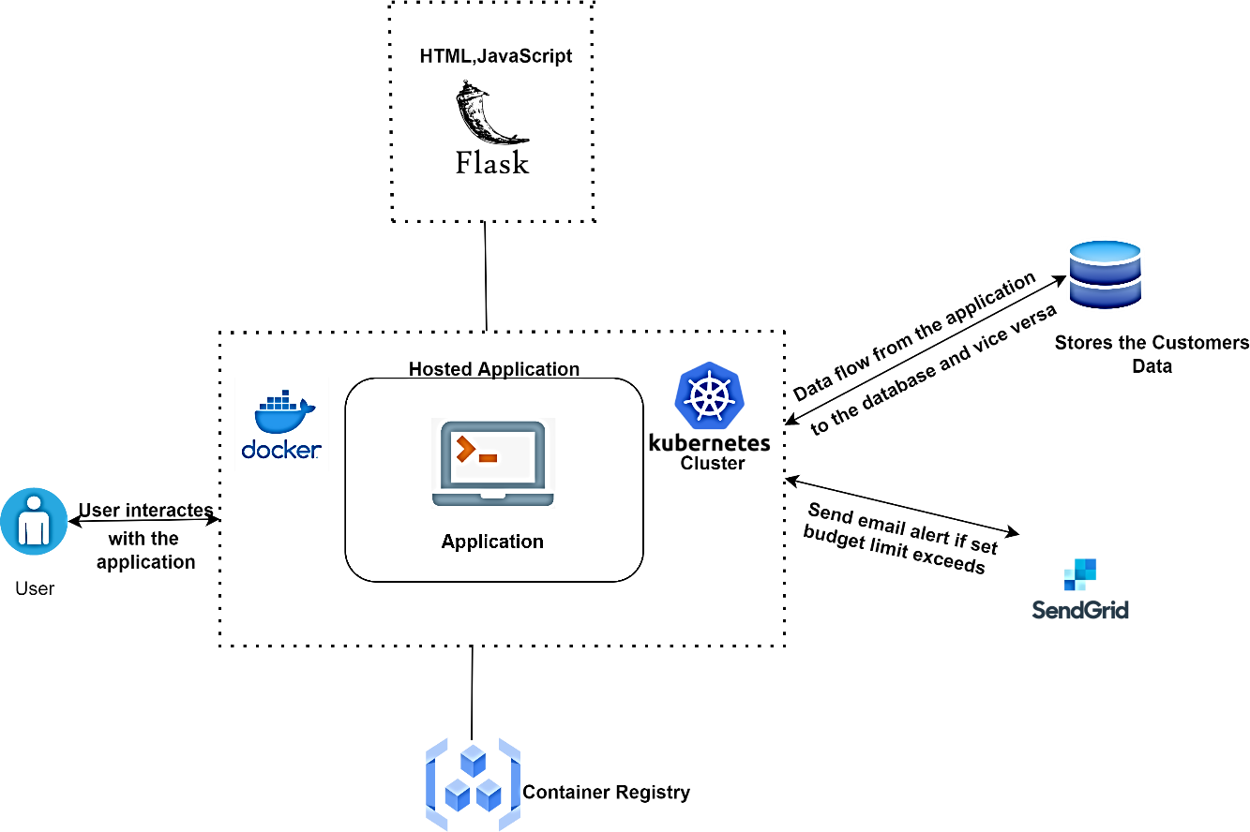

The above diagram represents the technology architecture of personal expense tracker application which is designed using html,css,javascript along with flask framework since it is web based application.After designing the web application it being deployed to the docker and managed with kubenetes.

The application interacts with the database for storing and retriving customer details and also stores cookies within the browser for improved application performance. The deployed application also has been integrated with the sendgrid services for sending mails to the user regrading their budget limit exceed.